


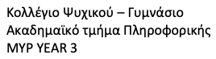


 | 9 | 6
 | 2 | 3
 | 2 | 3
 | 3 | 3

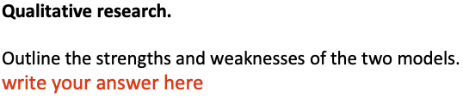
Both models are problematic in some ways. Model 1 has a variable in which we can only view changes if the correct number is selected, in opposition to Model 2, which has a slide variable that allows us to view all the significant changes produced when the variable is adjusted. In model 2 every change requires that we type it in but in the first model this can happen by just sliding and observating how we want to change it. Model two might have this weakness but the alarm is faster on model 2 and on model 1 it needs more tries.
The models represent the digitization of automation by using examples as scratch blocks.

