- Given a 1-indexed array of integers numbers that is already sorted in non-decreasing order, find two numbers such that they add up to a specific target number. Let these two numbers be numbers[index1] and numbers[index2] where 1 <= index1 < index2 < numbers.length. Return the indices of the two numbers, index1 and index2, added by one as an integer array [index1, index2] of length 2.
- You are given an integer array height of length n. There are n vertical lines drawn such that the two endpoints of the ith line are (i, 0) and (i, height[i]). Find two lines that together with the x-axis form a container, such that the container contains the most water. Return the maximum amount of water a container can store. Notice that you may not slant the container.
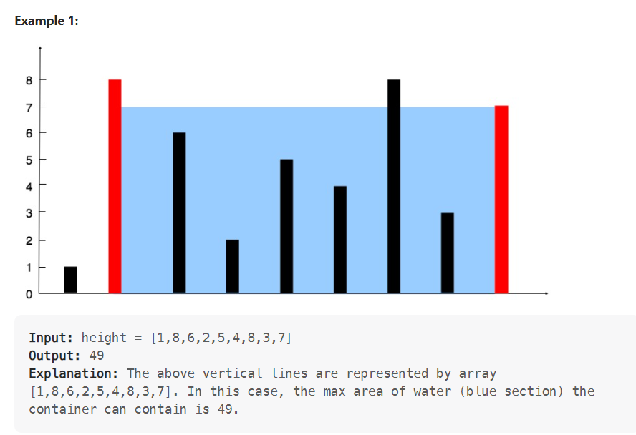
- Given an integer array nums, return an array answer such that answer[i] is equal to the product of all the elements of nums except nums[i].The product of any prefix or suffix of nums is guaranteed to fit in a 32-bit integer. You must write an algorithm that runs in O(n) time and without using the division operation.
Example
Input: nums = [1,2,3,4]
Output: [24,12,8,6]

